**Worksheet – 2.2**

**Student Name:** Vivek Kumar  **UID:** 21BCS8129

**Branch:** BE-CSE (LEET) **Section/Group:** 809/A

**Semester:** 4th **Date of Performance:** 28/03/2022

**Subject Name:** Computer Network Lab **Subject Code:** 20CSP-257

**1. Aim/Overview of the practical:**

Create different network topologies like Star, Bus and Mesh Topology with the help of packet tracer and show the output.

**2. Task to be done/ Which logistics used:**

* Implementation of All types of Topologies using Switch.

**Prerequisites:**

**S/W:**

* Laptop/Desktop
* CISCO Packet Tracer program

**H/W:**

* Main Memory - 128 MB RAM
* Hard Disk – minimum 20 GB IDE Hard Disk
* 44 MB Floppy Disk Drive
* –52X IDE CD-ROM Drive
* PS/2 HCL

**3. Steps for experiment/Code with Result/Output:**

**Setting Up:**

Follow the below steps to initiate the setup for the connection:

**Step 1:** Download Cisco Packet Tracer.

**Step 2:** Run and install the setup (You can be requested to log in to your Cisco Networking Academy Account or you can also log in as a guest).

**Step 3:** After the installation procedure has completed this display (below) will appear when you run the Cisco Packet Tracer-Start the application.

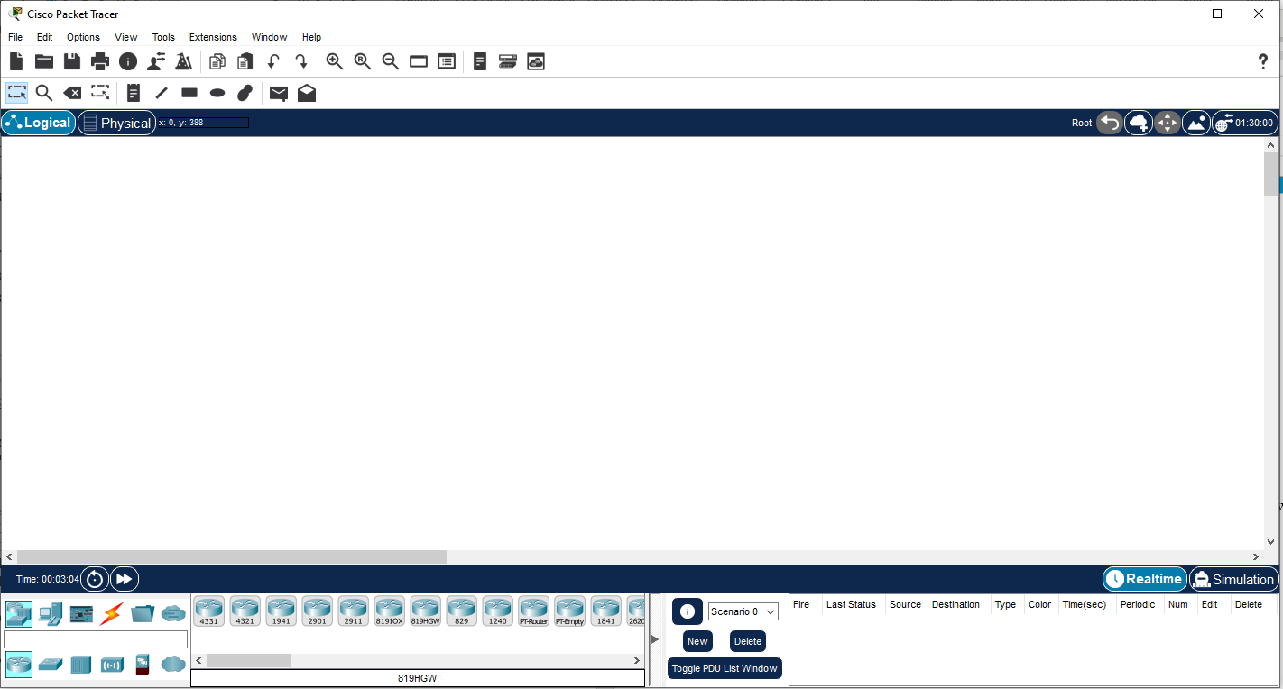

Cisco Packet Tracer

**Implementation of All types of Network Topologies like Star, Bus and Mesh:**

**Real Time Output is for Star Topology:**

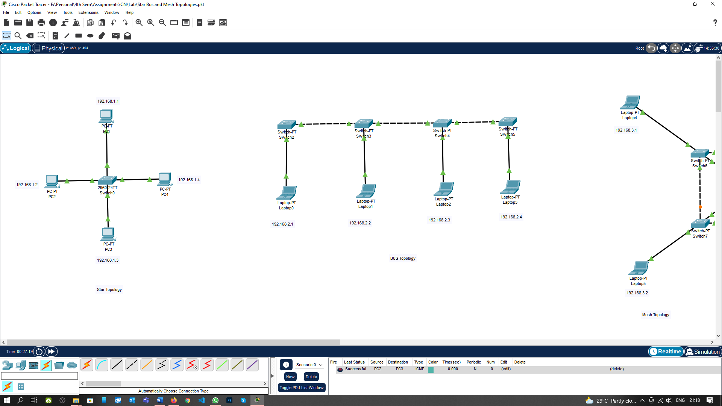

**Simulation Mode Output is for Star Topology:**

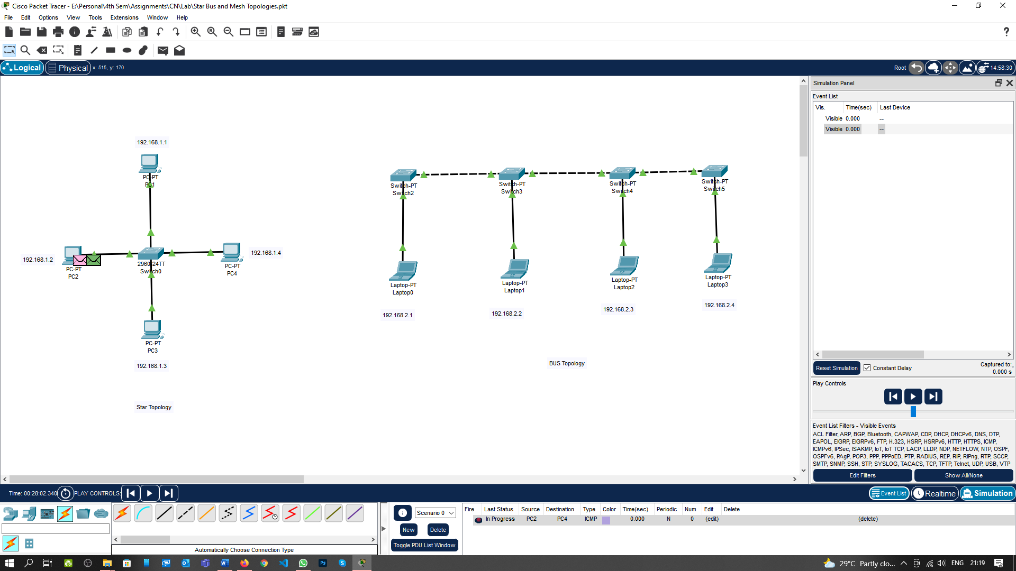

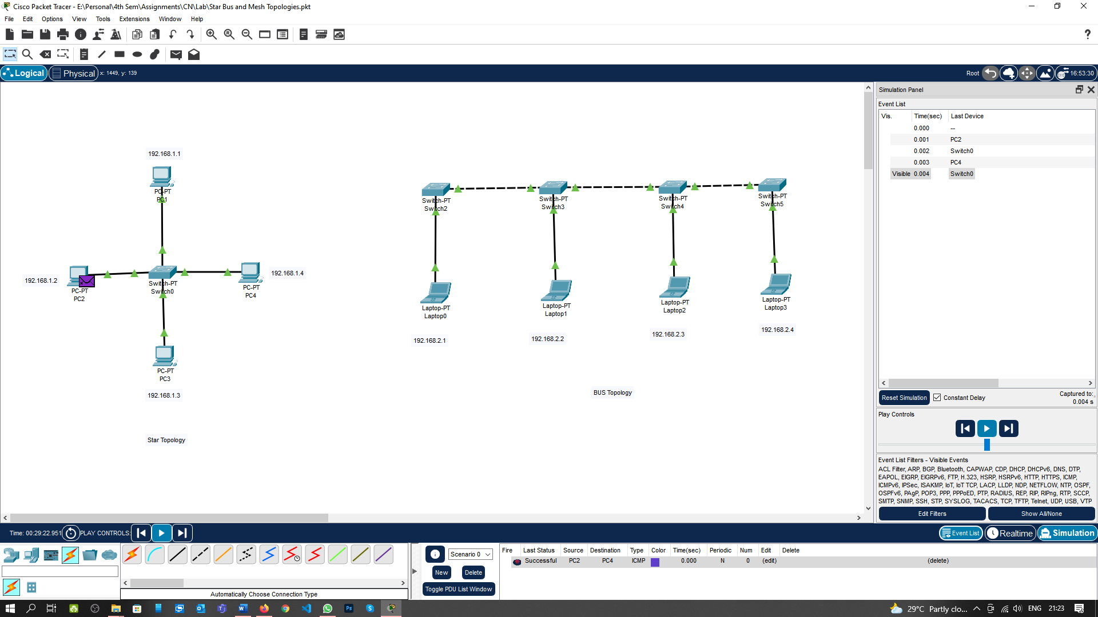

**Realtime mode output for Bus Topology:**

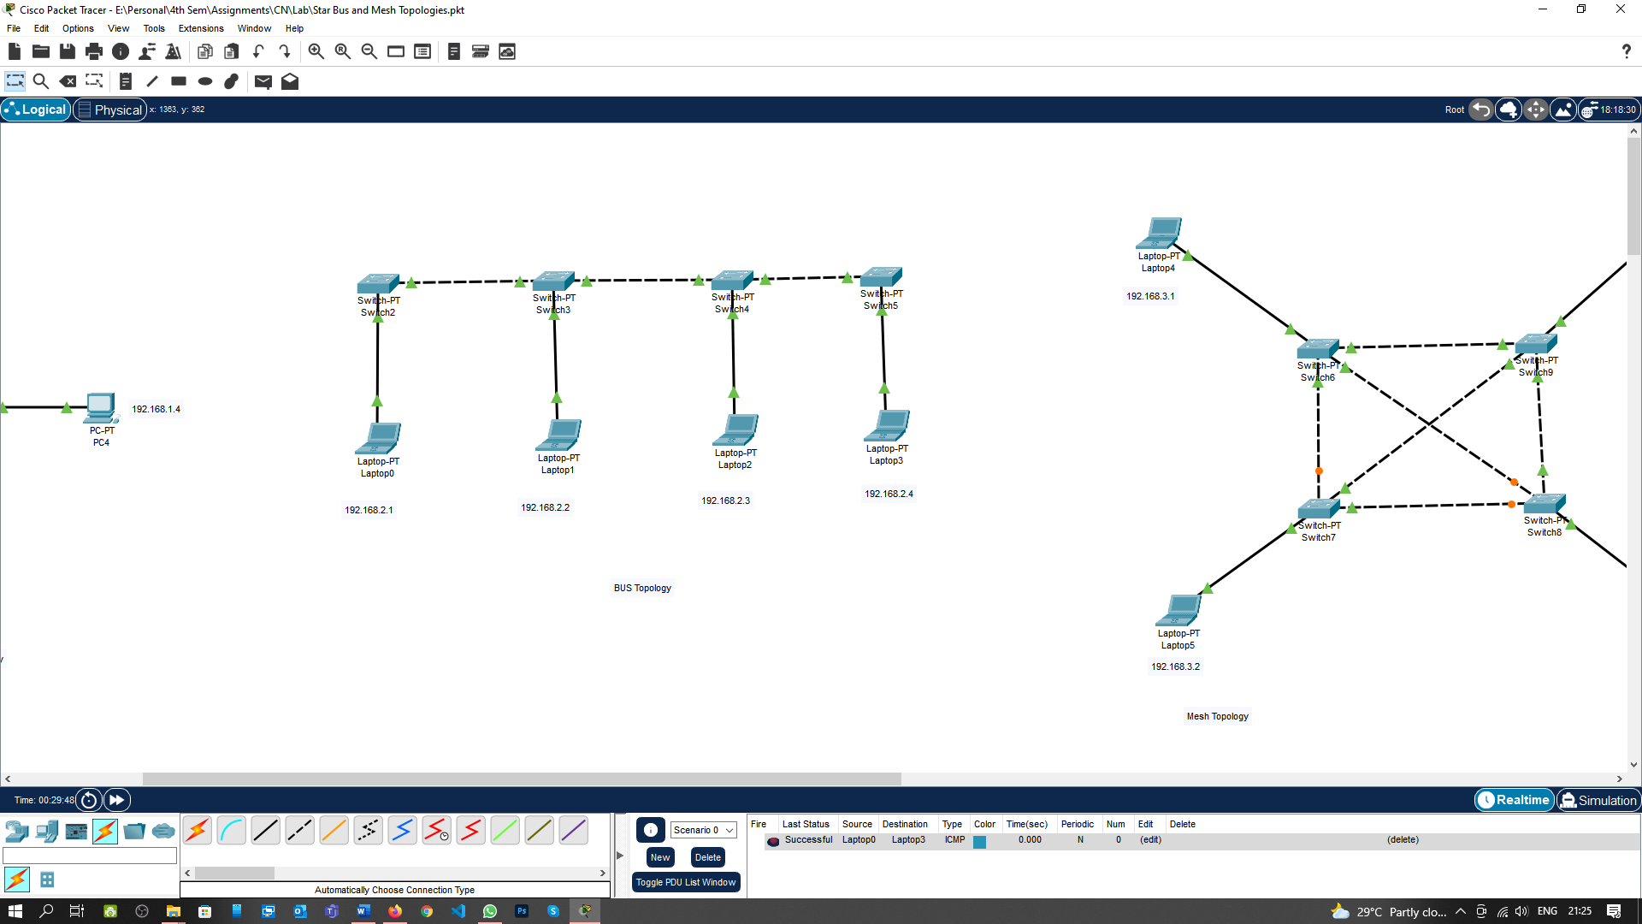

**Simulation Mode Output is for Bus Topology:**

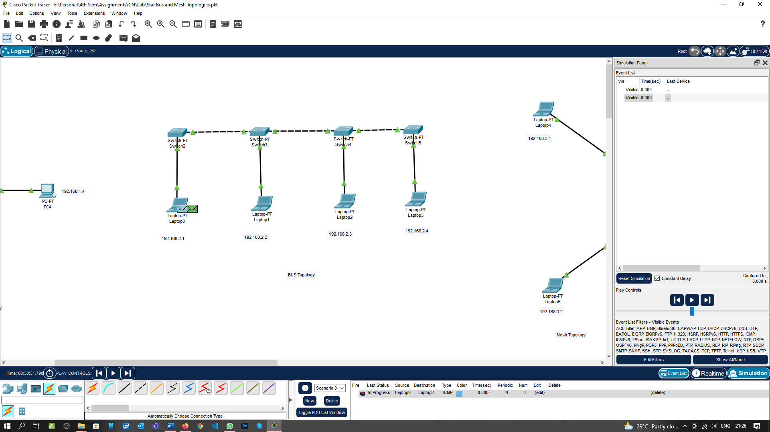

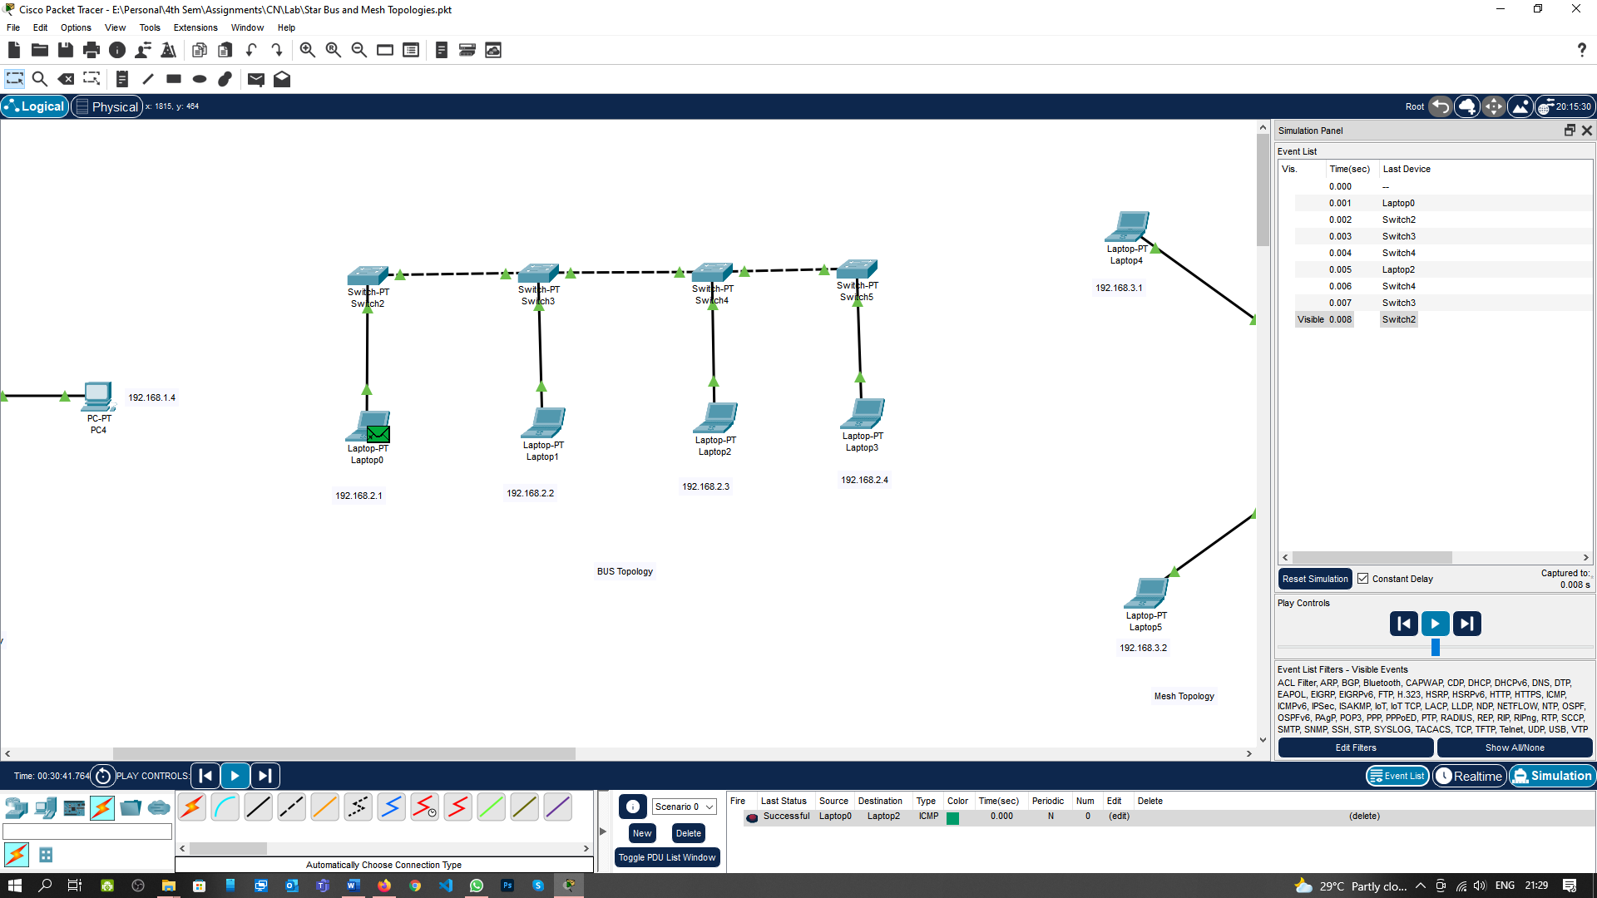

**Realtime mode output for Mesh Topology:**

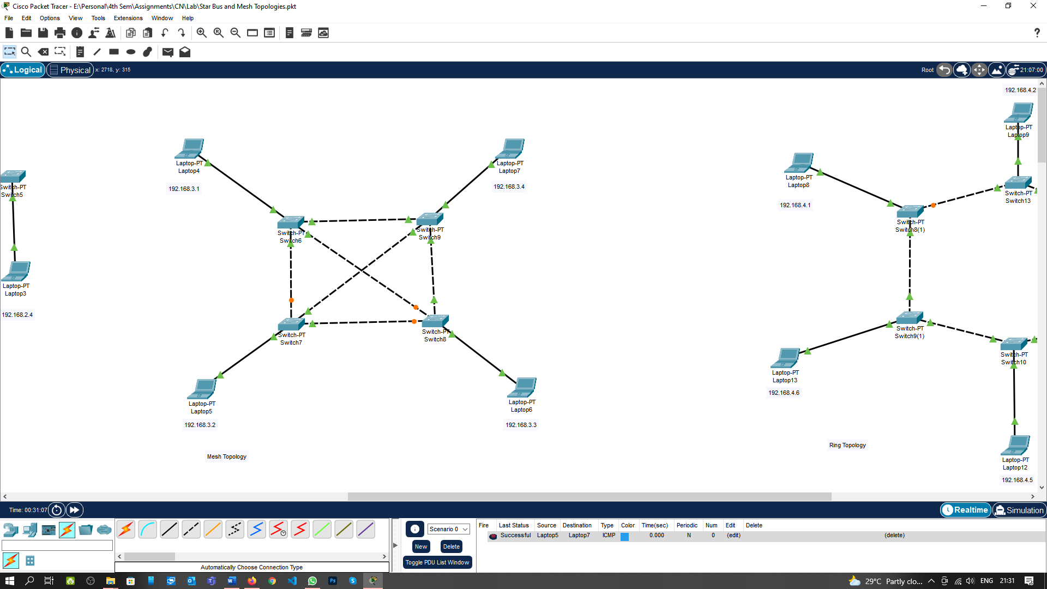

**Simulation Mode Output is for Mesh Topology:**

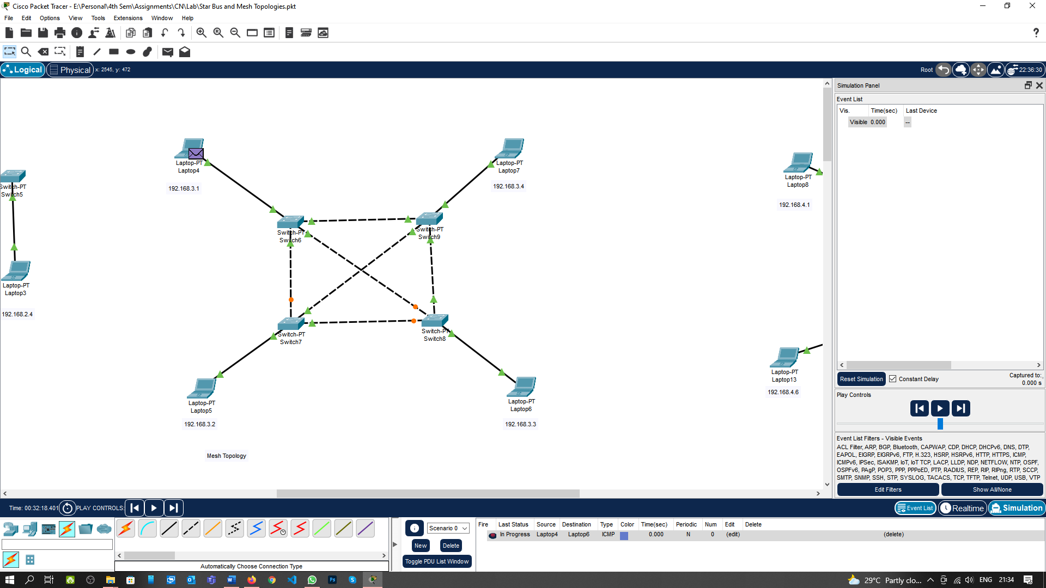

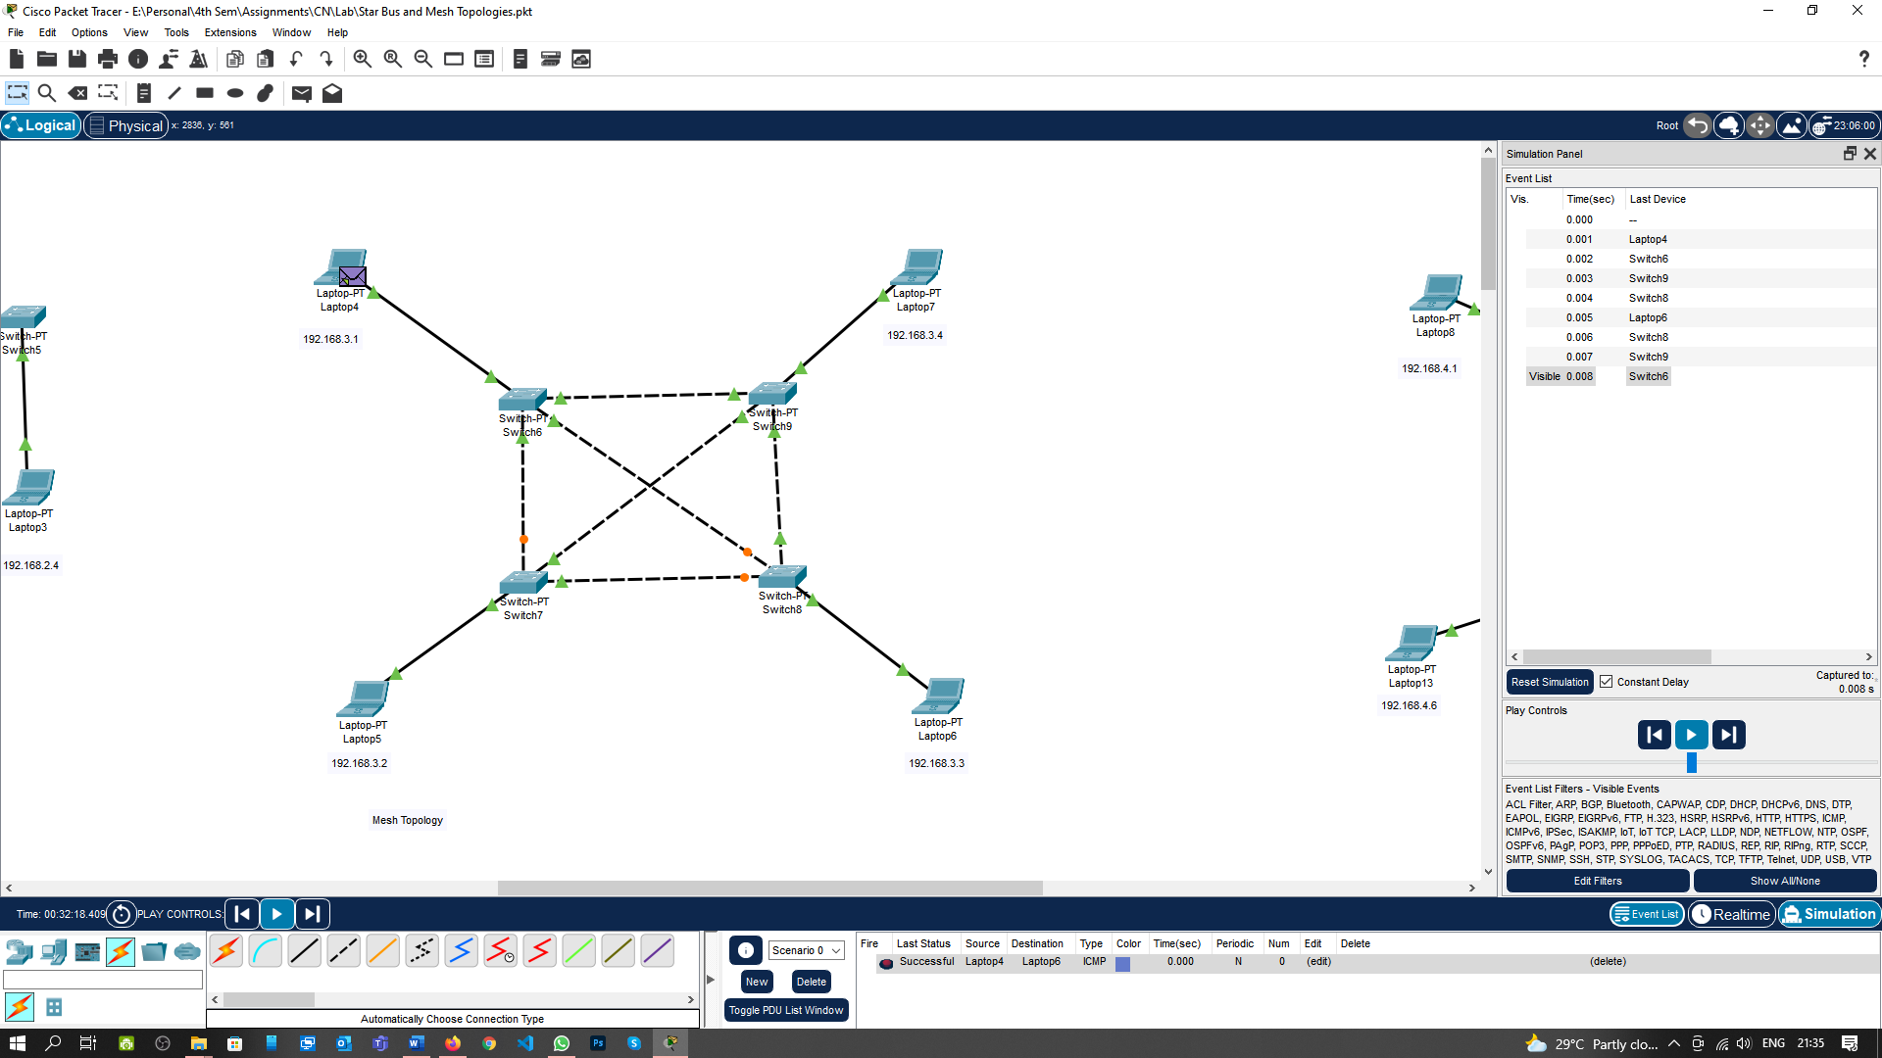

**Realtime mode output for Ring Topology:**

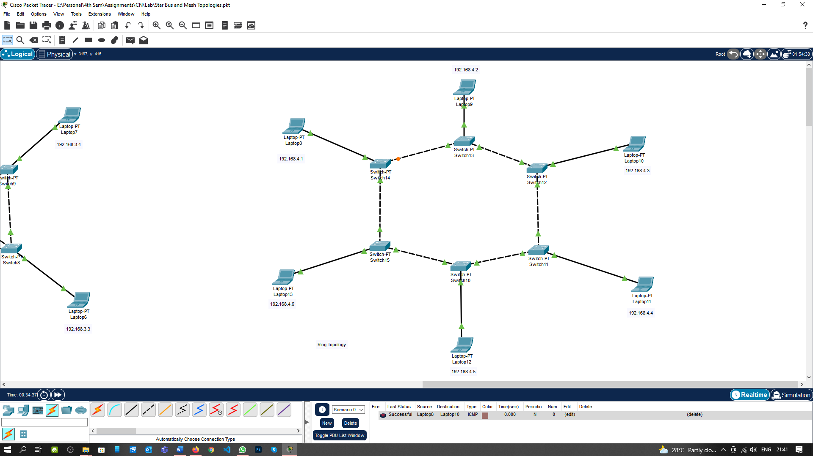

**Simulation Mode Output is for Ring Topology:**

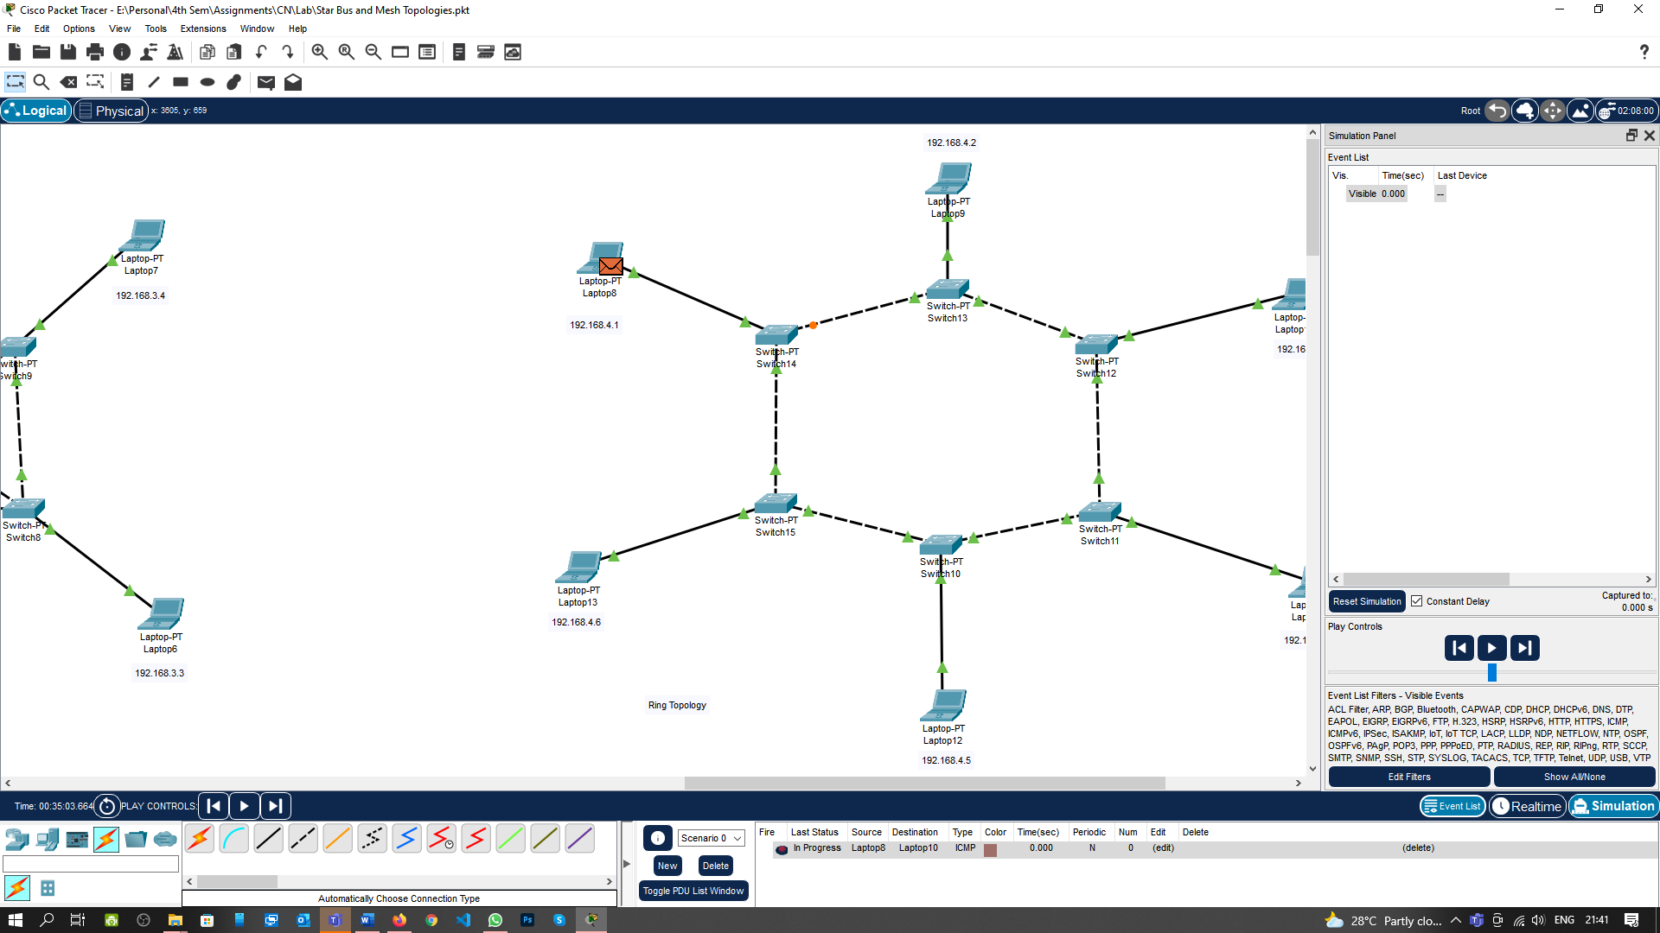

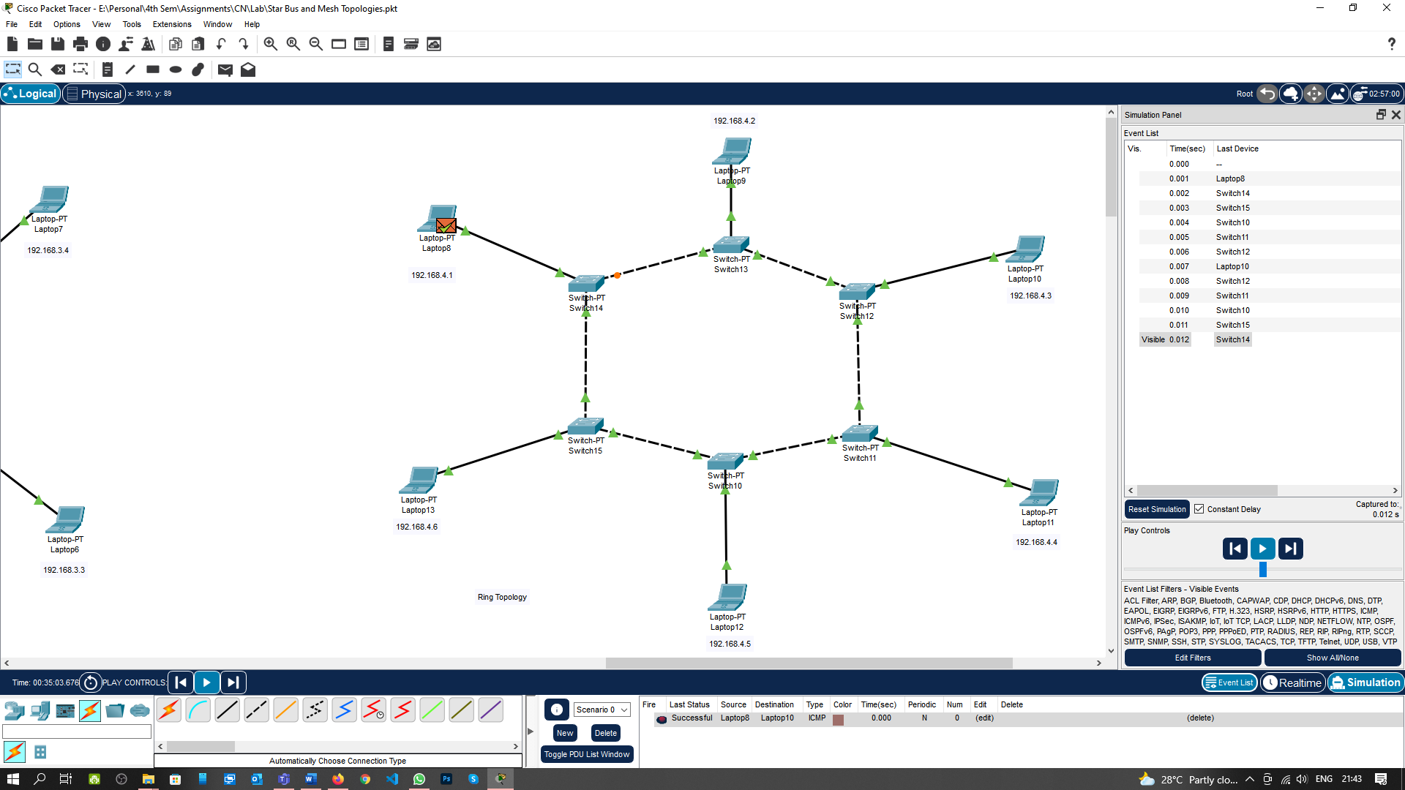

**Learning outcomes (What I have learnt):**

**1.** Understand working of network device Network Topologies.

**2.** Create and Executed all Network Topologies using switch.

**Evaluation Grid (To be created as per the SOP and Assessment guidelines by the faculty):**

|  |  |  |  |
| --- | --- | --- | --- |
| Sr. No. | Parameters | Marks Obtained | Maximum Marks |
| 1. |  |  |  |
| 2. |  |  |  |
| 3. |  |  |  |
|  |  |  |  |